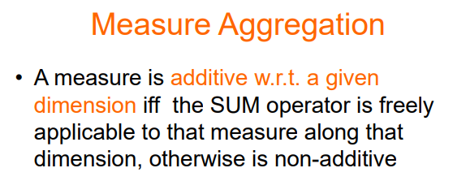

Each family tell which operations to use and which to not use

To categorize a measure is to find if it is additive or not additive
- An additive measure wrt to time/city/… if the sum operator makes sense. As an example, the quantity sold is an additive measure wrt time. If I fix all other dimensions and I vary time I can sum up the pieces sold for a larger time. Also sold is additive with city
- A non-additive measure wrt something else if it is not additive.
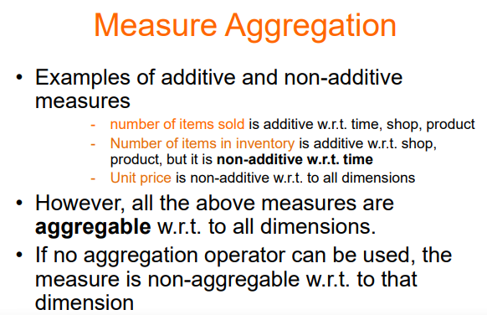
At specific time a specific item in a specific shop there are 10 pieces.

unit precise is non-additive wrt all dimensions.
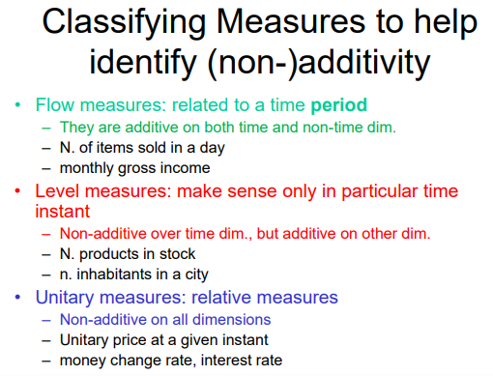
3 family of measures, tell which aggregable operations can be applied.

FLOW MEASURES
- numbers that vary across time, like a function

LEVEL MEASURE
- Values that make sense only at a particular time. Need a precise time instant to tell you the value
- Measure that are not additive over time but are additive in other dimensions
- Like products in store, in an interval does not make sense, but on a precise moment it has sense
- or number of people that live in a city, at a certain time it make sense, but on a period it does not (I can tell the average)

UNITARY MEASURE
- Not additive on all dimensions

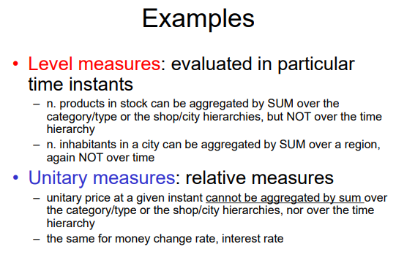

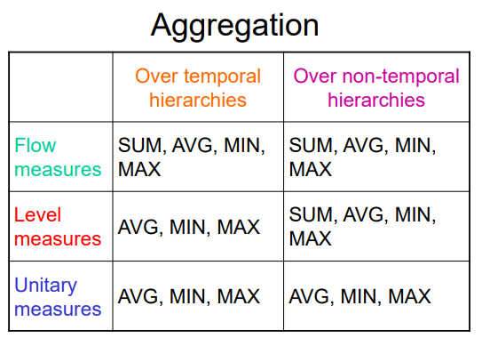
for flow measure can have all type of computation (sum, avg, min, max) for both temporal (time) or non-temporal hierarchies

For level measure we can use sum, avg, min and max for non temporal hierarchies. But with time dimension we can not use the sum

For unitary measures for time or non time dimension time can not be used

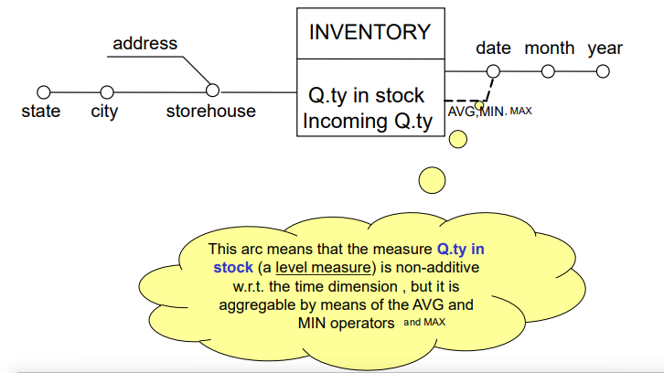
FACT: inventory, that is identified by the date and storehouse.

Quantity in stock is a level measure, making sense only on a specific time. With the dashed like I can tell that the only operators applicable are avg, min, and max

If I do not specifying anything it means every operator can be used

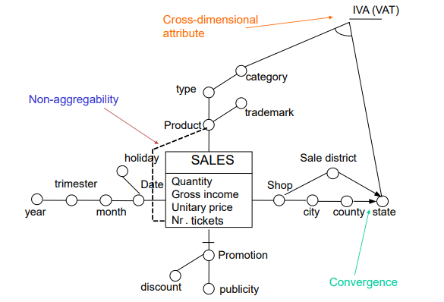

non-aggregability is some measure not aggregable no matter the operator we apply. We use dashed line with nothing specified. In the sale fact the number of tickets I sold on specific date in a certain shop a certain product.

Conceptual design

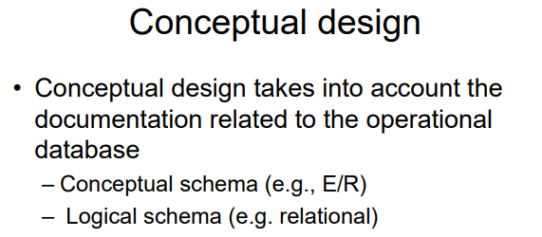

How we can produce a fact schema starting from previous information we have in our system.

Approach is almost identical, starting from conceptual or to logical schema.
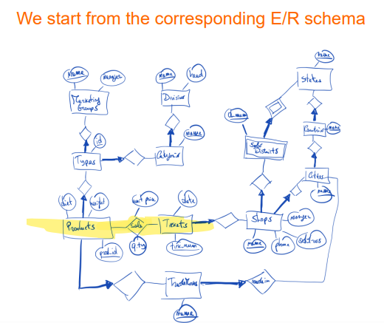

Example: database regarding selling. The key relationship is sales that connect a product to a receipt (texts).

describe the product sold (biscuits), the amount (10) and the unit price (1euro).

The recipient has a certain data and an id. The shop has one id, manager and one city. and cities are associated with one country that has one name and one state.

In this way we avoid redundancy.

Products have a weight and are associated with one type of product or not.

Category belong to one division (that works for specific categories)

A product has a trademark (company that produces the product) and has the HQ in a specific location.

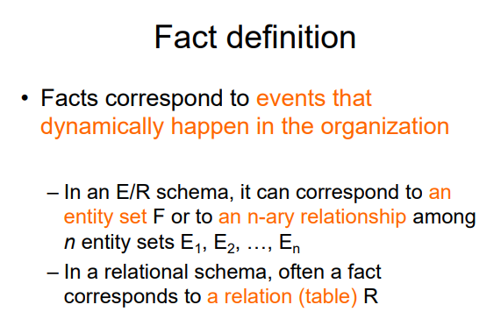

First we need to understand which is the fact of interest. It is something that changes very often. It is something relevant.

How to identify a fact in a E/R? it corresponds to an entity set or an n-ary relationship. It connects different entities.

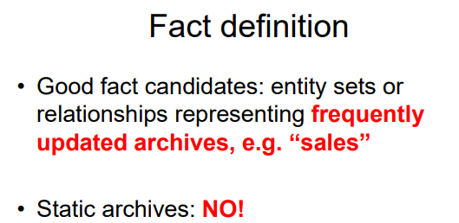

Status (does not change over time or contains data structured).

Shops are not really relevant

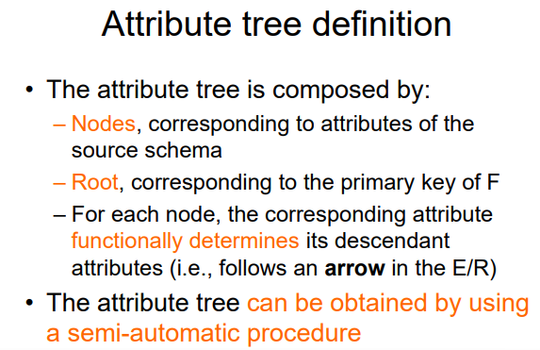
After identifying the good candidate for a fact we start with the process It is a semi-automatic process

After choosing the sale relationship as the fact we navigate the E/R diagram. Follow the E/R diagram starting from the fact. It will give a tree called attribute tree

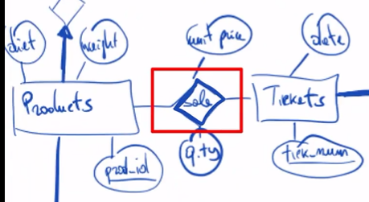

- The nodes are the attributes of the schema
- The root is the primary key
In the E/R diagram we follow an arrow, to build relation it should uniquely determined it should be thin or thick arrow (at most one)

If there is no arrow you have plenty of entity associated to the same and can not uniquely determine

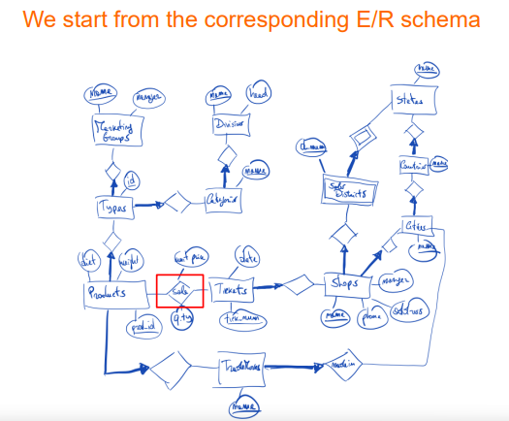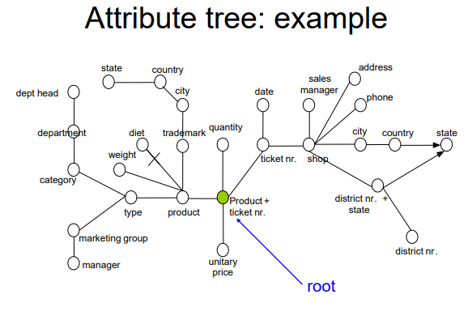

Node where the identity is the product + thicket number.

Connected all the attributes + all the entities connected to it.

Assume we know that diet attribute is possible null, while weight is not null in the schema.

Grow the tree in every direction that you have an arrow. No arrow can not grow

From the E/R the state of the district is different.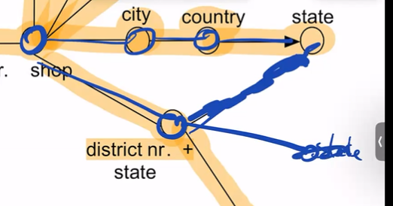

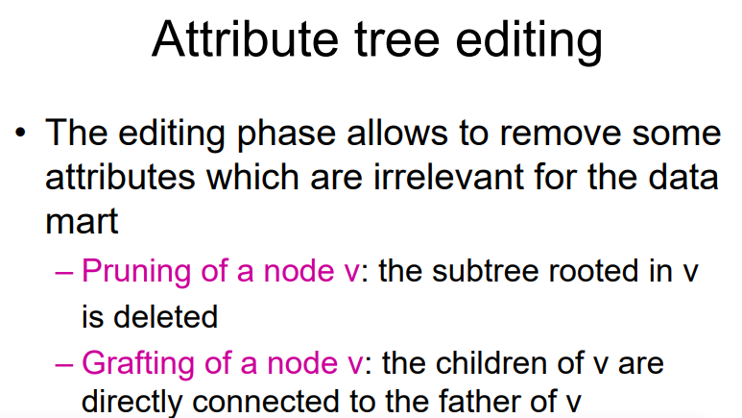

Two operations to apply on a tree
- Pruning: a certain attribute is useless, cut the tree at some point and all attributes below are removed
- Grafing: you do not need a very granular level but care about more general. Like you do not care about a specific product, you kill the node and all the children become children of the previous one. You remove one level of granularity

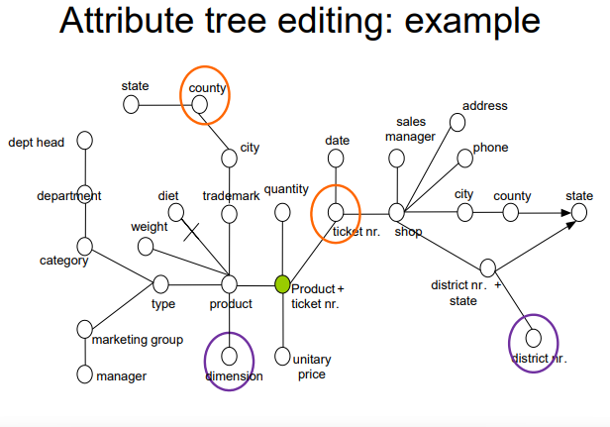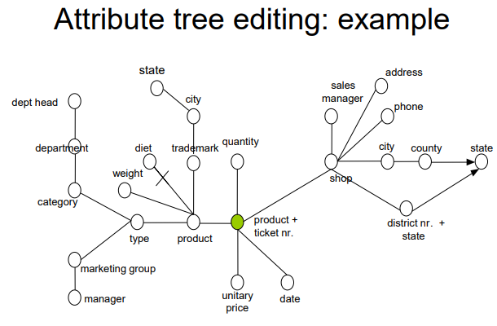

Example: pruning on purple and grafting on orange

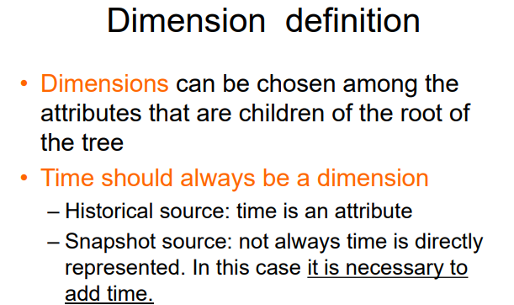

After choosing the tree we convert the tree in fact schema. Choose dimensions and values.

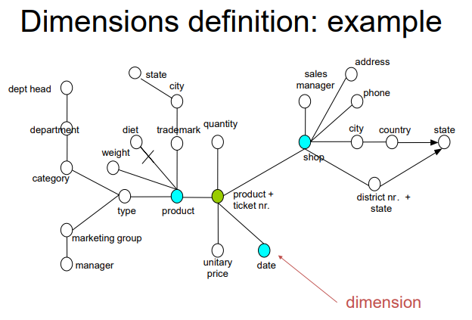
Time should be a dimension.

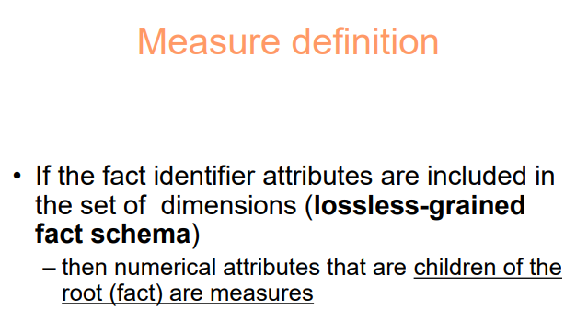

Lossless grained fact schema: keep maximum granularity

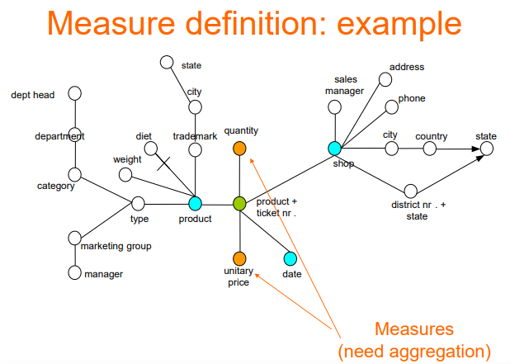

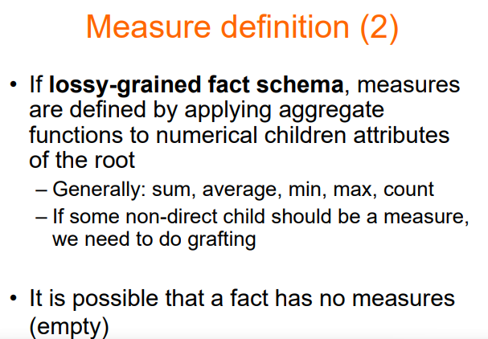

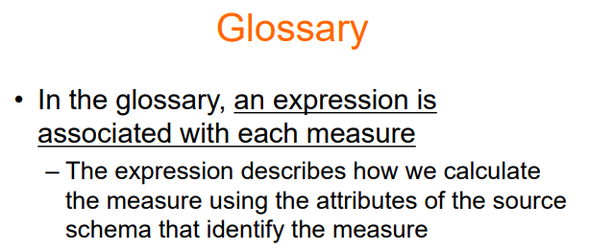
Give a glossary: how to compute the measures

